**PHARMACY MANAGEMENT SYSTEM LLD**

**Scope –**

**Project Objectives:**

1. Efficient Pharmacy Operations: Streamline and automate various tasks related to drug inventory management, order processing, and sales reporting to improve the efficiency of pharmacy operations.
2. User-Friendly Interface: Develop user interfaces that are intuitive and easy to use for both admin and doctor users, ensuring a positive user experience.
3. Data Security: Implement robust security measures to protect sensitive user data and maintain data integrity.
4. Accurate Sales Reporting: Generate accurate and detailed sales reports to provide insights into the pharmacy's financial performance.
5. Order Management: Allow doctors to place orders for drugs and enable admin users to verify and process these orders effectively.

**Functionalities In Scope:**

**For Admin User:**

* User authentication (login/signup).
* Drug management (add/edit/delete/view drugs).
* Supplier management (add/edit/delete/view suppliers).
* Order management (view doctor orders, verify orders, move orders to "Picked Up" section).
* Sales reporting (view, download, print reports).

**For Doctor User:**

* User authentication (login/signup).
* View available drugs.
* Place drug orders.

**Limitations and Exclusions:**

* Payment Processing: The system will not handle payment processing or financial transactions. It will focus on order placement and reporting.
* Prescription Handling: The system will not validate or process prescriptions; it assumes that doctors have valid prescriptions when placing orders
* Integration with External Systems: Integration with external healthcare systems or electronic health records is not within the scope of this project.
* Inventory Forecasting: The system will not include advanced inventory forecasting or demand planning features.

**Deliverables:**

* Software Application: The fully functional Pharmacy Management System with user interfaces for admin and doctor users.
* Documentation: Detailed documentation, including system design, user manuals, and installation guides.
* Training: Training materials and sessions for pharmacy staff to use the system effectively.
* Support and Maintenance: Ongoing support for bug fixes, updates, and maintenance after the initial deployment.

**Key Modules –**

**For both Admin and Doctor User .

**1. User Authentication Module:**

* Admin Login/Signup: Implement user authentication for admin, including registration and login functionality with proper validation of credentials.
* Doctor Login/Signup: Implement user authentication for doctor users with registration and login functionality.

**2. Drug Management Module:**

* **Add Drug:**

Input: Drug details (name, dosage, quantity, price, etc.).

Process: Validate and add drug information to the database.

* **Edit Drug:**

Input: Drug ID and updated details.

Process: Update the drug information in the database.

* **Delete Drug:**

Input: Drug ID.

Process: Remove the drug entry from the database.

* **View Drugs:**

Process: Retrieve and display the list of drugs from the database.

**3. Supplier Management Module:**

* **Add Supplier:**

Input: Supplier details (name, contact, address, etc.).

Process: Validate and add supplier information to the database.

* **Edit Supplier:**

Input: Supplier ID and updated details.

Process: Update the supplier information in the database.

* **Delete Supplier:**

Input: Supplier ID.

Process: Remove the supplier entry from the database.

* **View Suppliers:**

Process: Retrieve and display the list of suppliers from the database.

**4. Order Management Module:**

* **View Doctor Orders:**

Process: Retrieve and display orders placed by doctor users, including order details and status.

* **Verify Orders:**

Input: Order ID.

Process: Check the validity of the order, update its status, and verify it.

* **Add Order to Picked Up Section:**

Input: Order ID.

Process: Move the order to the "Picked Up Orders" section and update its status.

**5. Sales Reporting Module:**

* **View Sales Report:**

Process: Generate and display sales reports based on various criteria (e.g., date range, drug category).

* **Download/Print Sales Report:**

Input: Report type and format (PDF, Excel).

Process: Generate and provide the option to download or print the selected sales report.

**6. Order Placement Module (Doctor User):**

* **View Drugs:**

Process: Retrieve and display the list of available drugs to the doctor user.

* **Place Order:**

Input: Selected drugs and quantities.

Process: Create a new order with the selected drugs and submit it for admin review.

**7. Database Management:**

* Implement a relational database to store user information, drug details, supplier information, order data, and sales records.

**8. User Interfaces:**

* Design user-friendly interfaces for both admin and doctor users to access the system's functionalities.

**9. Security:**

* Implement secure authentication and authorization mechanisms to protect user data and system functionality.

**10. Error Handling:**

* Include error handling and validation throughout the system to provide feedback to users and prevent data inconsistencies.

**11. File Management:**

* Implement file storage for sales reports, allowing users to download and print reports in various formats.

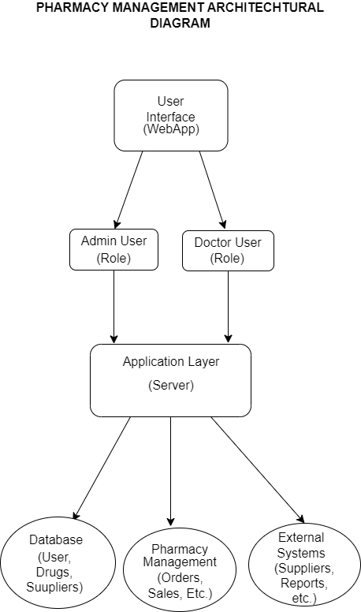

Use Case Diagram Pharmacy Management System

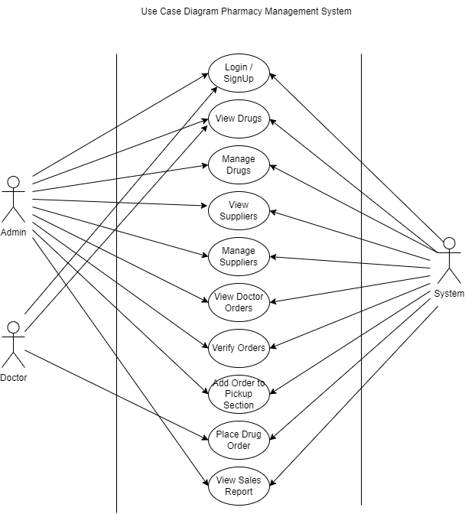

Data Flow Diagram Pharmacy Management System

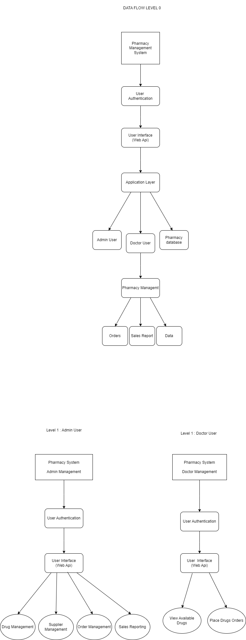

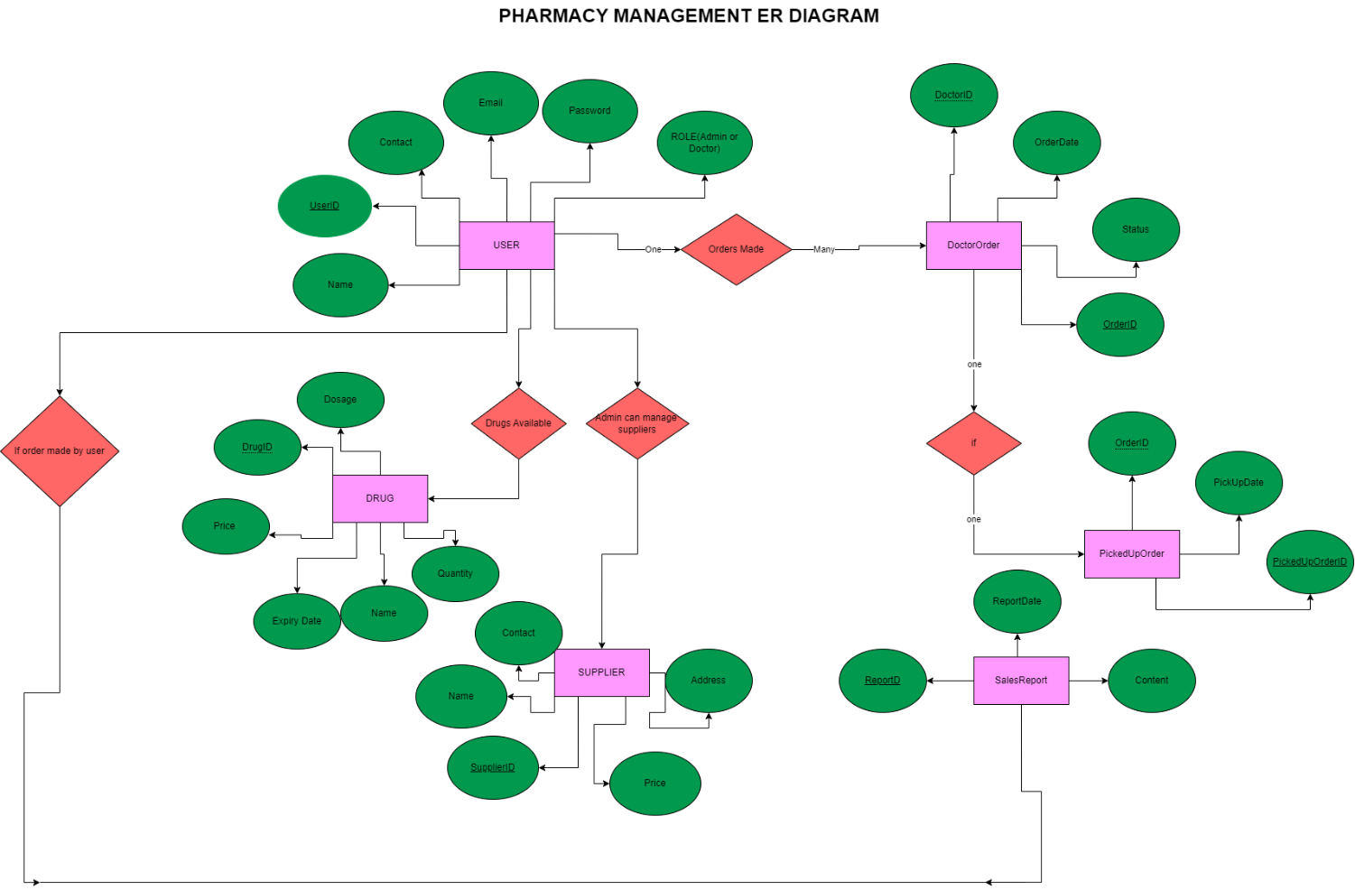

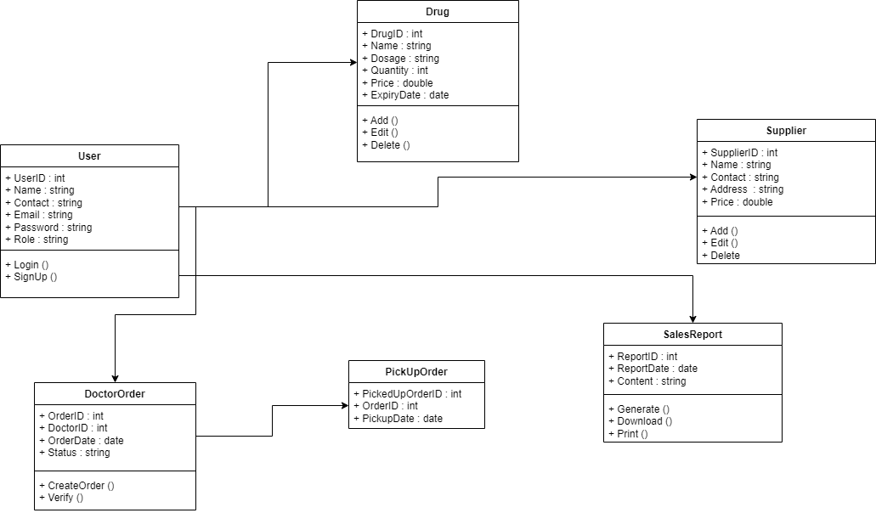

Class Diagram Pharmacy Management System